Applying the Neural Network Method in Analyzing the Preferences of Food Store Customers

Karim Layegh Ahani1, Younos Vakil Alroaia2, Abolfazl Danaie3,* and Farshad Faezi Razi4

|  |
| --- |
| **Citation**: Layegh Ahani, K., Vakil Alroaia, Y., Danaie, A., & Faezi Razi, F. (2025). Applying the Neural Network Method in Analyzing the Preferences of Food Store Customers *. Business, Marketing, and Finance Open,* 2(6), 1-23.  Received: 01 April 2025  Revised: 03 July 2025  Accepted: 05 July 2025  Published: 01 November 2025    **Copyright:** © 2025 by the authors. Published under the terms and conditions of Creative Commons Attribution-NonCommercial 4.0 International ([CC BY-NC 4.0](http://creativecommons.org/licenses/by-nc/4.0)) License. |

1 Department of Management, Se.C., Islamic Azad University, Semnan, Iran; **[](https://orcid.org/0009-0003-6568-6998)**

2 Department of Management, Se.C., Islamic Azad University, Semnan, Iran; **[](https://orcid.org/0000-0003-3249-6509)**

3 Department of Management, Se.C., Islamic Azad University, Semnan, Iran; **[](https://orcid.org/0000-0001-9973-3877)**

4 Department of Management, Se.C., Islamic Azad University, Semnan, Iran; **[](https://orcid.org/0000-0002-9397-5645)**

**\*** Correspondence: a.danaei@semnaniau.ac.ir

**Abstract:** The primary goal of the present study is to use the neural network method in analyzing the preferences of customers of food chain stores. Valuable customers were identified using neural network methods and clustering methods. Then, valuable customers were classified by classification methods. Then, the preferences of valuable customers were identified. It was done by the association rules approach. Additionally, using classification and clustering methods, useful patterns were found to identify and analyze the behavior of outbound and non-outbound customers. After a series of data preparation and pre-processing operations, each customer's information and their transactions were determined. The primary data were based on each customer's transaction. After the data preparation and pre-processing operations, a set of data was obtained that was related to each customer and recorded their information. Neural network methods were used to classify valuable customers and leaving customers and this network was compared with other methods. Concerning K-means clustering, the output of this algorithm could identify valuable customers and analyze the customers who left or were loyal. Association rules were also used for the cluster of valuable customers to identify the preferences of valuable and non-leaving customers.

**Keywords:** Customer preferences, Neural network method, Chain stores, Valuable customers

# Introduction

In an increasingly competitive retail landscape, understanding customer preferences has become central to enhancing consumer satisfaction, improving customer retention, and refining strategic marketing initiatives. Businesses today no longer thrive on product superiority alone; rather, they must integrate technological tools to interpret consumer behavior dynamically. With the explosion of consumer data and advances in artificial intelligence (AI), especially in machine learning (ML), analyzing customer preferences with high accuracy has become not only possible but also essential for long-term viability. Traditional survey-based methods of understanding customer choices are being replaced—or significantly augmented—by data-driven analytical models capable of detecting nuanced behavioral trends and predicting future actions [1, 2].

Within this context, neural networks have emerged as powerful tools for deciphering complex and nonlinear customer behaviors by learning patterns from historical transactional data. These models offer the ability to cluster, classify, and predict customer segments, especially valuable in domains where consumer behavior varies widely across product categories and shopping contexts [3]. For example, in food retail chains, where customers exhibit diverse preferences and shopping frequencies, neural networks can help uncover underlying patterns that traditional methods might overlook. The strength of such approaches lies in their ability to learn from data without being explicitly programmed with rule-based logic, making them ideal for capturing hidden relationships among variables [2].

A key advantage of machine learning in preference analysis is the ability to segment customers based on not just their explicit demographic characteristics but also their implicit behavioral traits—how often they shop, what they purchase, the sequencing of their purchases, and their reaction to pricing strategies. Models like clustering algorithms, decision trees, and backpropagation neural networks can uncover latent patterns in massive datasets [4]. In particular, combining classification techniques with clustering and association rule mining allows businesses to derive comprehensive insights: identifying not only valuable customers but also those at risk of churn, and tailoring engagement strategies accordingly [5].

Churn prediction, in fact, has become a focal point in the study of customer behavior analytics. High customer turnover is detrimental to long-term profitability, and understanding the triggers for churn is critical to devising effective retention strategies. Several researchers have used hybrid models that combine supervised learning techniques with clustering to predict customer exit patterns with commendable accuracy [6-8]. In a related development, studies have integrated neural networks with fuzzy logic systems and ant colony optimization techniques to enhance credit scoring and behavioral prediction, underscoring the relevance of advanced modeling in customer analytics [9].

Moreover, consumer preference modeling is no longer static; it demands continuous recalibration. As purchasing behaviors evolve due to social trends, economic shifts, or seasonal demands, the analytical frameworks must also adapt. Research has proposed dynamic models of preference analysis using deep learning and collaborative filtering to integrate real-time inputs from multiple sources, including IoT devices and social networks [10]. These approaches underscore the importance of leveraging multiple data streams in building robust models for customer-centric decision-making.

Another significant advancement in this domain is the integration of business intelligence (BI) systems with AI-driven modeling. BI maturity frameworks now include modules for preference analytics, allowing for strategic alignment between operational decisions and market needs [11]. This integration facilitates the transition from descriptive to predictive and even prescriptive analytics, wherein organizations not only interpret what has happened but also anticipate future outcomes and prescribe optimal actions.

Customer value segmentation further enhances the ability to allocate resources strategically. By combining Recency, Frequency, and Monetary (RFM) metrics with machine learning, companies can prioritize engagement strategies for high-value customers while deploying churn prevention tactics for at-risk segments [12, 13]. Moreover, the ability to predict the impact of pricing on customer choice through neural networks has opened new frontiers in personalized recommendation systems, allowing businesses to align their offerings more closely with customer sensitivities [2].

Notably, researchers have underscored the importance of feature selection and dimensionality reduction techniques such as Principal Component Analysis (PCA) to enhance model efficiency and accuracy [14]. In data-intensive environments like retail chains, where each transaction can have dozens of associated variables, intelligent feature engineering becomes vital. For instance, identifying key variables such as product categories, time of purchase, seasonal patterns, and customer interaction history enables more precise segmentation and forecasting [15].

Furthermore, advances in sequential pattern mining allow for the extraction of frequent purchase sequences, enabling the generation of association rules that inform cross-selling and up-selling strategies [16]. When combined with neural networks, these rules can form the basis of intelligent recommendation engines tailored to individual customer profiles. These hybrid systems do not merely enhance customer satisfaction; they also lead to substantial improvements in operational efficiency and marketing ROI [17].

A unique contribution to the current study is its focus on integrating customer preference analysis with churn prediction and value segmentation in a unified model. Unlike studies that treat these components in isolation, the integrated framework employed here allows for a holistic view of customer life cycle management. For example, a customer might exhibit high monetary value but also show churn tendencies; such insights are only possible through a multi-dimensional analysis using neural networks and clustering models in tandem [4, 5].

The applicability of such integrated models extends beyond retail. Broadcast industries, telecommunications, and e-commerce platforms have successfully implemented similar models to address churn and personalize service delivery [1, 12, 18]. The scalability and adaptability of these models are enhanced by the use of open-source tools and platforms such as RapidMiner and Tableau, which facilitate the visualization and transformation of high-dimensional customer data.

Importantly, preference modeling is increasingly being used not only for predicting product interest but also for informing the design and development of new products. This shift toward co-creation reflects the broader trend of involving customers more directly in the innovation process. Studies have demonstrated how customer-generated data can inform product features, aesthetics, and even branding strategies through intelligent data mining techniques [2, 14].

Despite the promising prospects, some challenges remain. Data quality and integration issues can compromise the effectiveness of machine learning models. Moreover, ethical concerns related to privacy and algorithmic bias must be carefully addressed when collecting and analyzing customer data. Nevertheless, with appropriate governance frameworks and transparent modeling practices, these challenges can be mitigated to maximize the value extracted from customer data [8].

In light of the above, the present study endeavors to apply a hybrid analytical framework incorporating neural networks, clustering algorithms (like K-means and SOM), and association rule mining to analyze customer preferences in a food chain retail setting. Drawing upon a rich dataset of over half a million customer transactions from a regional chain store, the study aims to classify customers based on their value and churn risk while simultaneously uncovering their purchasing preferences.

# Methodology

Based on recent studies, this study presents a hybrid model of data-mining algorithms and machine learning to analyze the value, default, and preference of customers. Previous studies have separately used data mining techniques for each of the above three concepts. However, a hybrid model is needed to consider simultaneously the value, default, and preference of customers. In this model, using data mining techniques, it is possible to identify valuable patterns in the large volume of customer data. Patterns can identify valuable customers. Also, defaulting and non-defaulting customers are identified, and finally, the preferences of valuable and non-defaulting customers are discovered. Companies may separately analyze customers based on their value the degree of default, and their preferences. However, in some cases, customers may be valuable but the degree of default has not been calculated. Also, companies cannot identify the preferences of valuable customers and it makes customer leaves the company and this customer becomes one of the defaulting customers. Figure (1) shows the conceptual model of the study.

**Figure 1. Research conceptual model**

As shown in Figure (1), data mining and machine learning techniques are first used to analyze customer datasets. Appropriate machine learning and data mining techniques were used in this study. After applying machine learning algorithms, valuable patterns are identified in the dataset. Companies can use the proposed model of this study to identify and determine the important characteristics of their customers.

Steps of the research proposed model

The research methodology is based on data mining and machine learning methods.

1. First, chain stores are analyzed. The primary goal is to identify the preferences of valuable customers and their leaving.

2. In the next step, customer data are collected. This dataset is located in the database of the store's customers.

3. Then, data are pre-processed.

4. In the fourth stage, modeling is done. First, customer segmentation is done based on preferences, leaving, and value of customer using the clustering methods.

It means that customers who are more similar to each other, their preferences and reasons for leaving may also be similar. After the clustering of customers, it is possible to classify the preferences and leaving of customers for each cluster using neural networks such as MLP, RBF, and other machine learning methods.

5. The results are compared and the best performance is determined to identify the valuable customer and predict the customer's preference and leaving.

6. In the last stage, by using the obtained results, recommendations and strategies are presented regarding customer preferences and their leaving, and a strategy is developed for valuable customers.

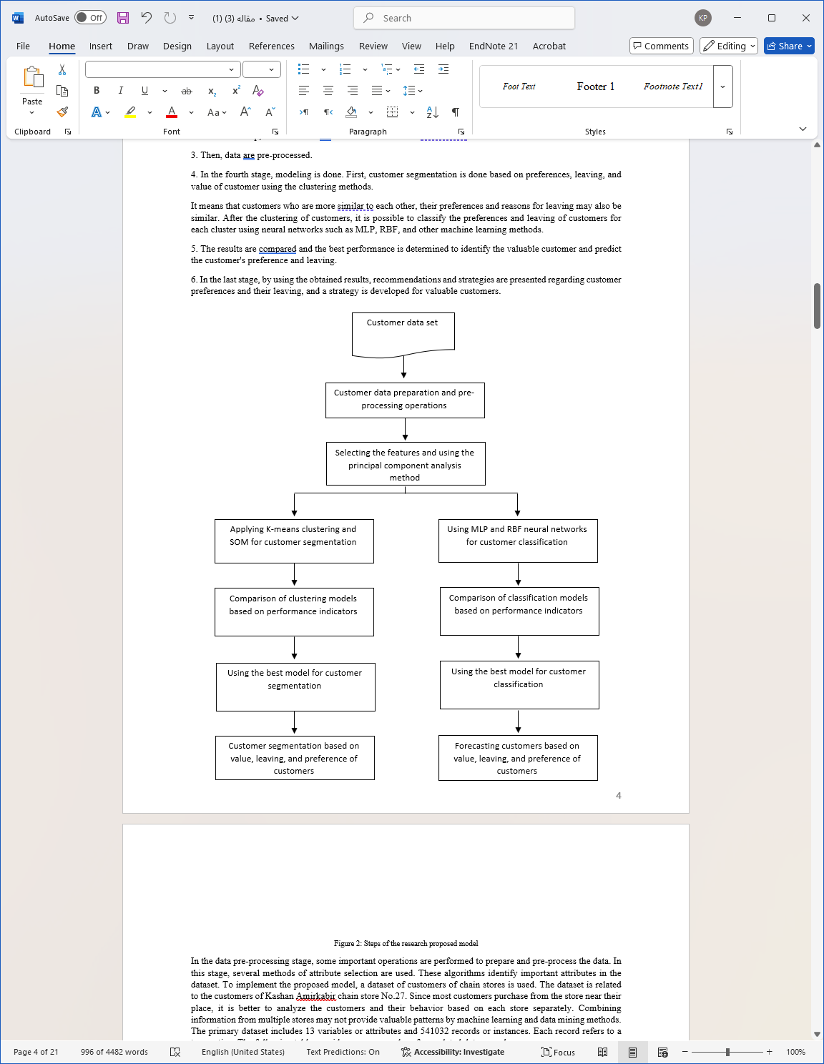

**Figure 2. Steps of the research proposed model**

In the data pre-processing stage, some important operations are performed to prepare and pre-process the data. In this stage, several methods of attribute selection are used. These algorithms identify important attributes in the dataset. To implement the proposed model, a dataset of customers of chain stores is used. The dataset is related to the customers of Kashan Amirkabir chain store No.27. Since most customers purchase from the store near their place, it is better to analyze the customers and their behavior based on each store separately. Combining information from multiple stores may not provide valuable patterns by machine learning and data mining methods. The primary dataset includes 13 variables or attributes and 541032 records or instances. Each record refers to a transaction. The following table provides some examples of completed data records.

**Table 1. Some examples of completed data records**

|  |  |  |  |  |  |  |  |  |  |  |  |
| --- | --- | --- | --- | --- | --- | --- | --- | --- | --- | --- | --- |
| Store name | Goods name | Product barcode | Customer number | Season | Month | Day of week | Day | Net sales amount | Last date of sale (date) | Total number of products sold | number of sales invoice |
| 27 Kashan Amirkabir | Butter Pak 25 g | 6260063200821 | 9010222018 | Summer | August | Thursday | 20 | 61,009 | 14010520 | 1 | 1 |
| 27 Kashan Amirkabir | Polywash active laundry liquid 2500 g, 6 pieces, purple | 6262825805695 | 9010222018 | Summer | August | Thursday | 20 | 878,642 | 14010520 | 1 | 1 |
| 27 Kashan Amirkabir | Crispy Minoo 125 g, 25 pieces | 6260100103306 | 9010222018 | Summer | August | Thursday | 20 | 91,743 | 14010520 | 1 | 1 |
| 27 Kashan Amirkabir | Lavender washing machine powder for deep cleaning, 500 g | 6260105004974 | 9010222018 | Summer | August | Thursday | 20 | 142,824 | 14010520 | 1 | 1 |
| 27 Kashan Amirkabir | pasteurized butter 25 g | 6260161539946 | 9010222018 | Summer | August | Thursday | 20 | 60,853 | 14010520 | 1 | 1 |
| 27 Kashan Amirkabir | Ghanche Plus sunflower Tocopherol liquid oil 1350 g | 6260101802659 | 9010222018 | Summer | August | Thursday | 20 | 963,900 | 14010520 | 1 | 1 |
| 27 Kashan Amirkabir | Saei low-absorption frying oil 810 g | 6260295101705 | 9010222018 | Summer | August | Thursday | 20 | 613,040 | 14010520 | 1 | 1 |

Machine learning and data mining methods are used to determine customer preferences, customer value, and customer leaving after data preparation and pre-processing and based on the proposed model. The number of records is 541013 transactions and the number of variables or attributes is six. Then, we define a record for each customer using the pivot operation. We changed the dataset so the rows represent the customers and the columns represent the variables related to each customer. Tableau software is used for this purpose. Before using it, to convert the month values into numbers, we use the filtering method and, for example, we set April equal to 1 and until September, which is equal to 6.

# Findings and Results

In this section, according to the proposed model in the third chapter, some classification methods are presented using neural network methods and the RBF model to find appropriate classification patterns in the dataset.

1- Classification models can predict and classify based on the purchase or non-purchase of any of the goods. Thus, we consider one of the goods as the target attribute and other attributes as independent variables. The results of the implementation in the neural network are as follows. Here, for example, we consider item 2200170 as the target attribute. We do the following steps: First, we use the decision tree.

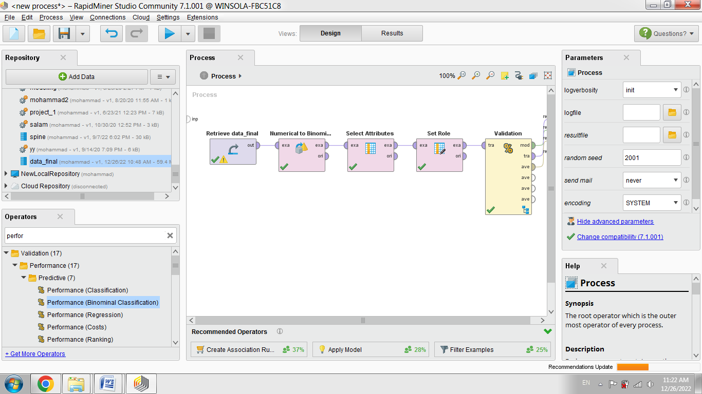

We also take the following steps in the validation section.

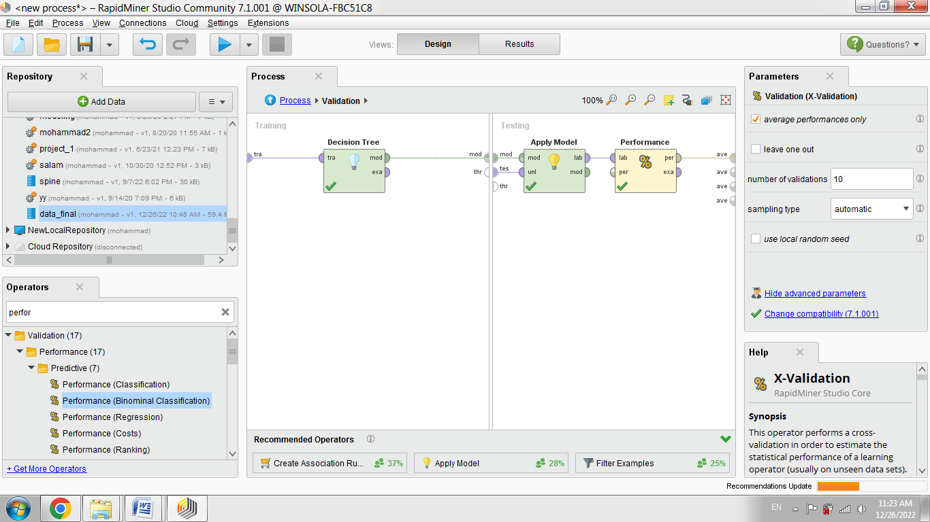

The results are as follows:

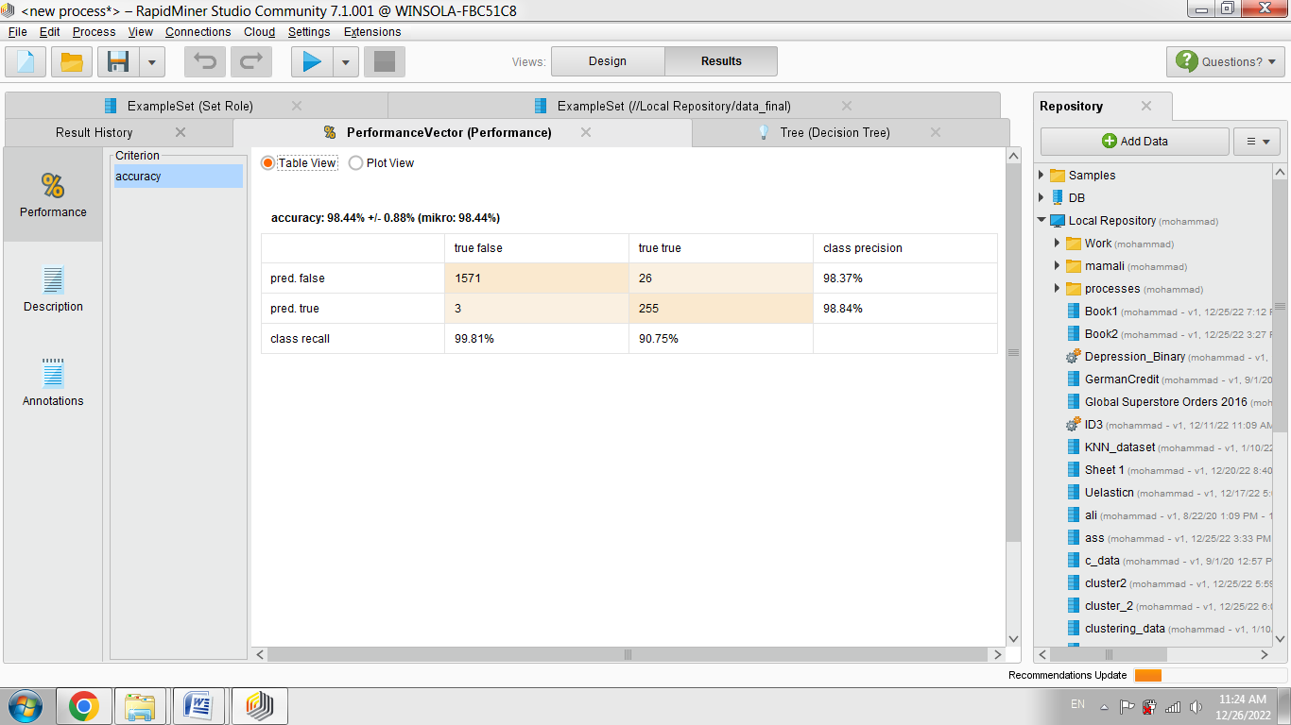

As seen, the accuracy of the decision tree is 98.44. The decision tree is as follows:

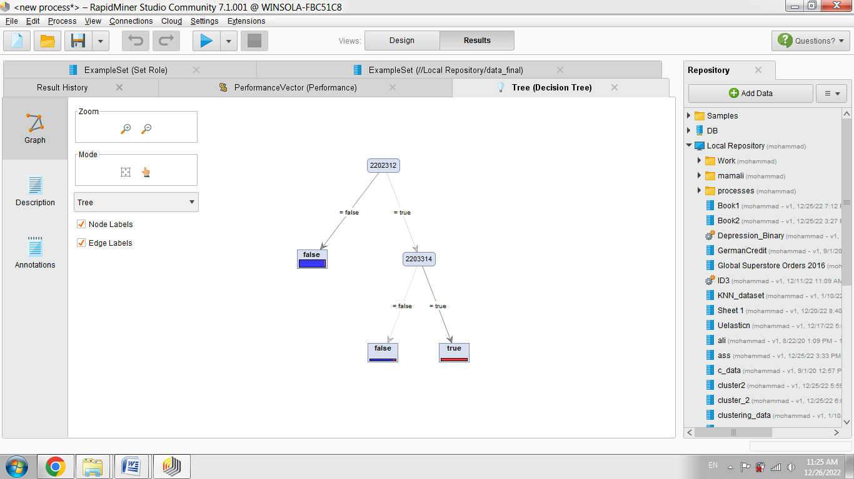

If item 2202312 is purchased, and item 2203314 is also purchased, item 2200170 is also purchased. If item 2202312 is not purchased, and item 2203314 is not purchased, item 2200170 is also not purchased.

2. Customers can be classified based on each of the RFM variables separately. It means that each of these values should be considered separately as a target attribute. For example, consider variable F as the target attribute and determine other attributes as independent variables. The results of customer classification are presented in the following tables. We do this as an example for variable F1. First, this variable should be discretized and divided into several intervals. In this method, goods variables are considered as independent variables and discrete F1 variable as dependent variable. The goal is to design a model that predicts which goods will be purchased. It is predicted that the F1 value will increase or decrease in the future. First, 100 attributes or products that can be more related to attribute F1 are identified. Then, using these 100 products, a classification model is built to predict the number of customer transactions. The results are as follows. The accuracy of the model is about 86%.

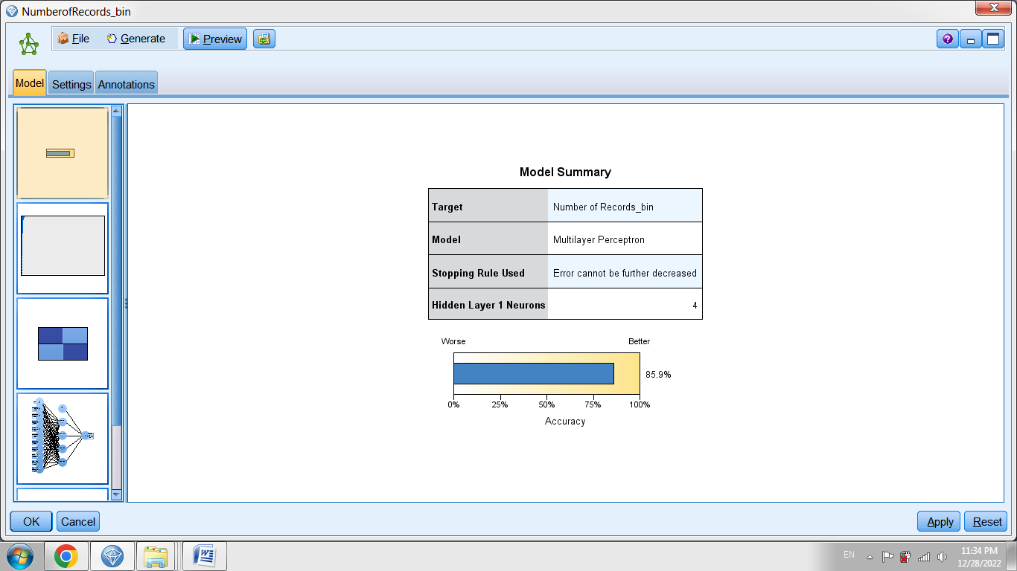

The important variables or goods related to the F1 attribute are as follows:

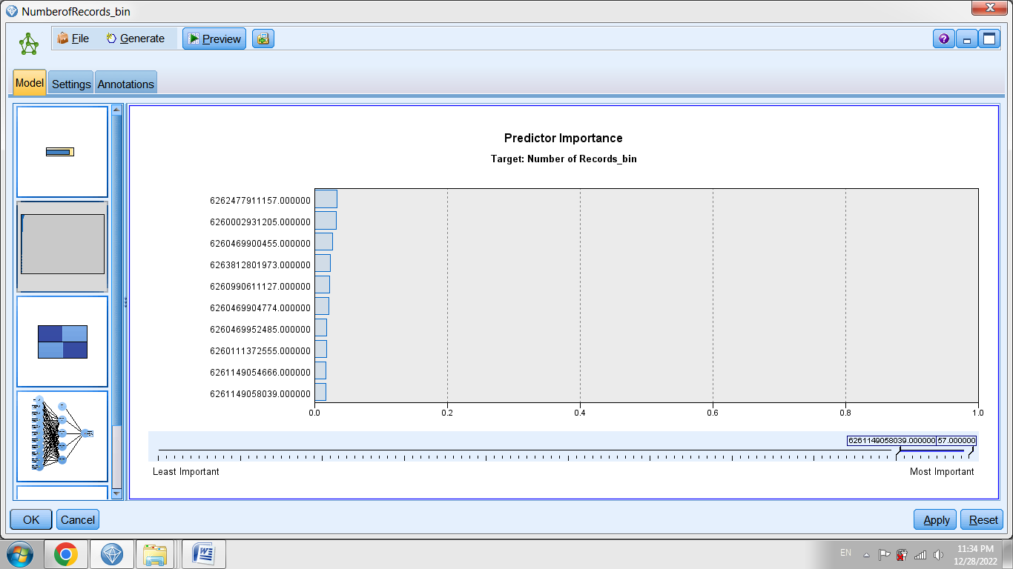

The confusion table to determine the classification accuracy is as follows:

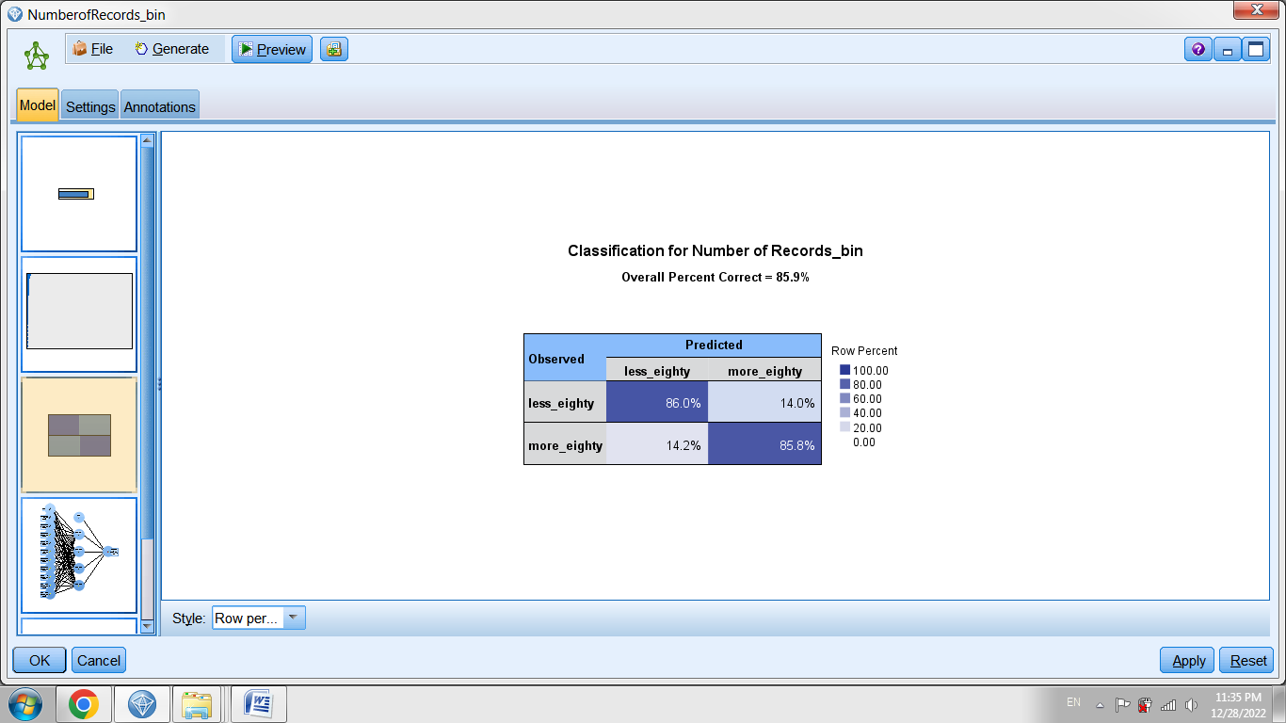

The structure of the neural network is as follows.

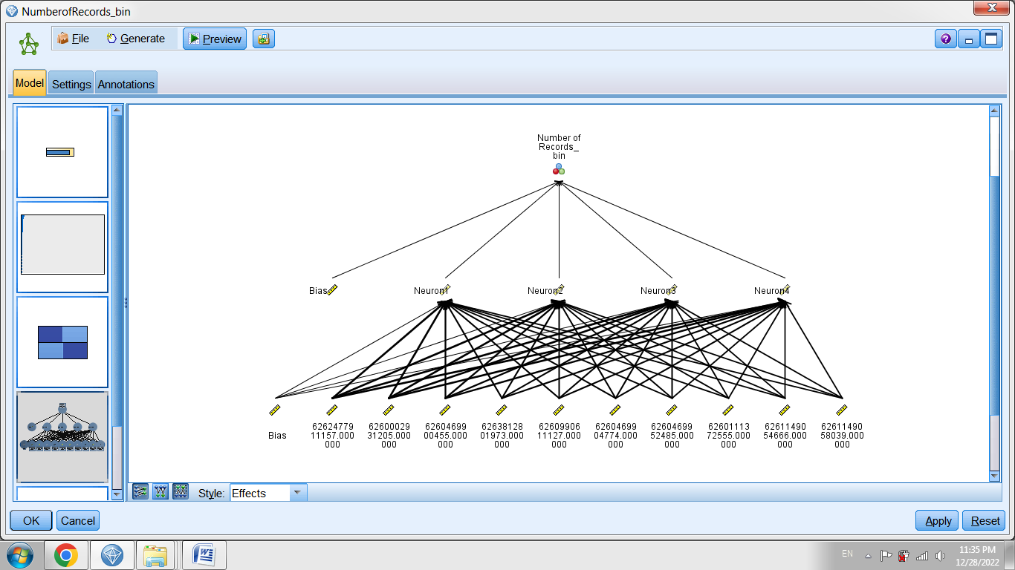

3- The target variable can be determined as one of the purchased goods. For example, it determines which customers purchase one of the specified goods. Thus, customers can be classified based on other customer characteristics and the rules and patterns governing the purchase of a specific product can be determined in the dataset. The results of the implementation of this classification model in the neural network are as follows. Item 2200170 is considered an output or target attribute.

The output of the neural network model

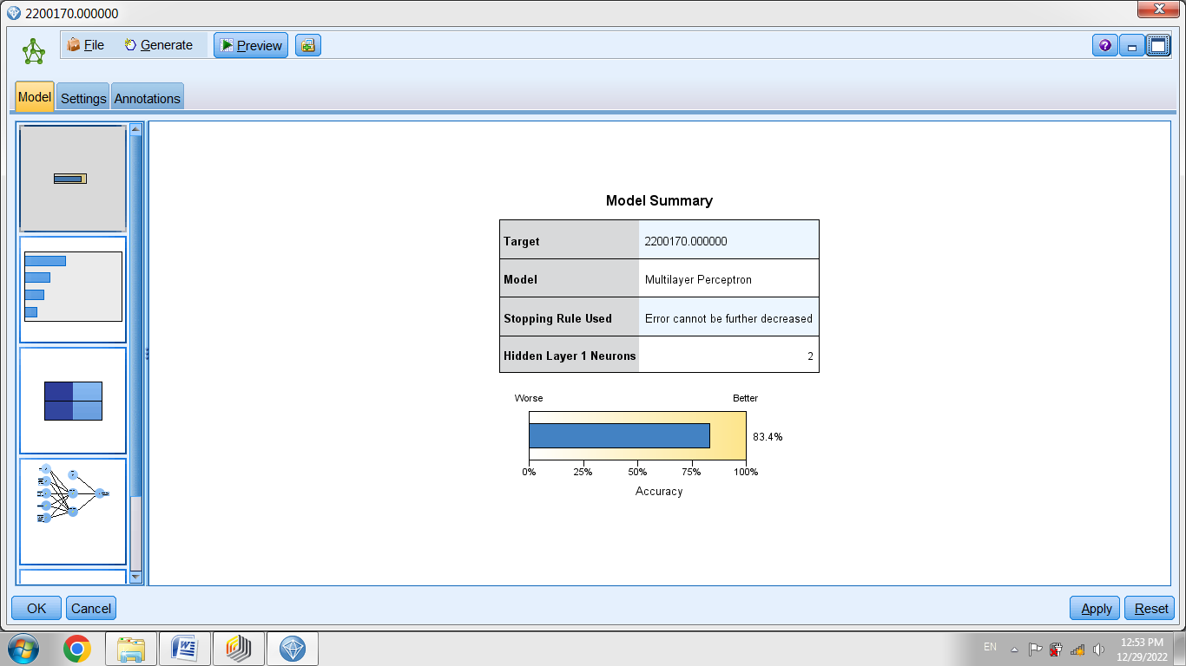

Importance of variables

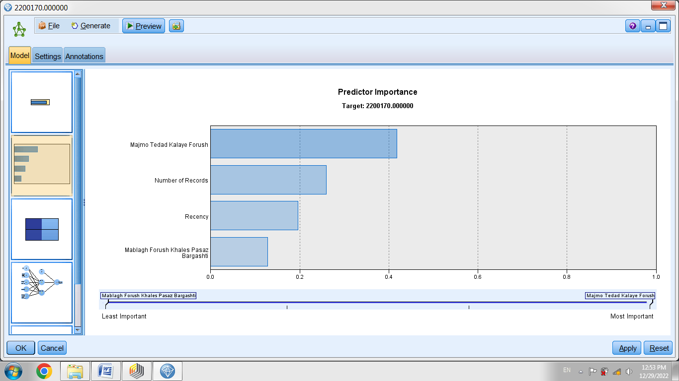

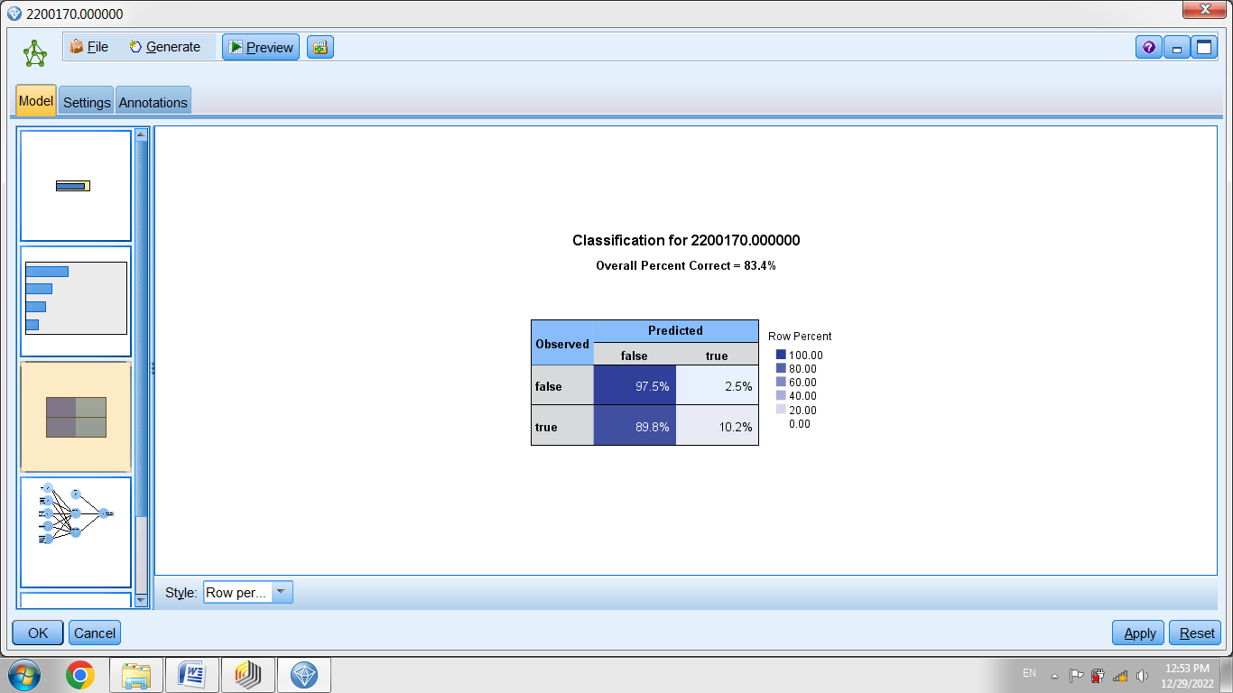

Network structure

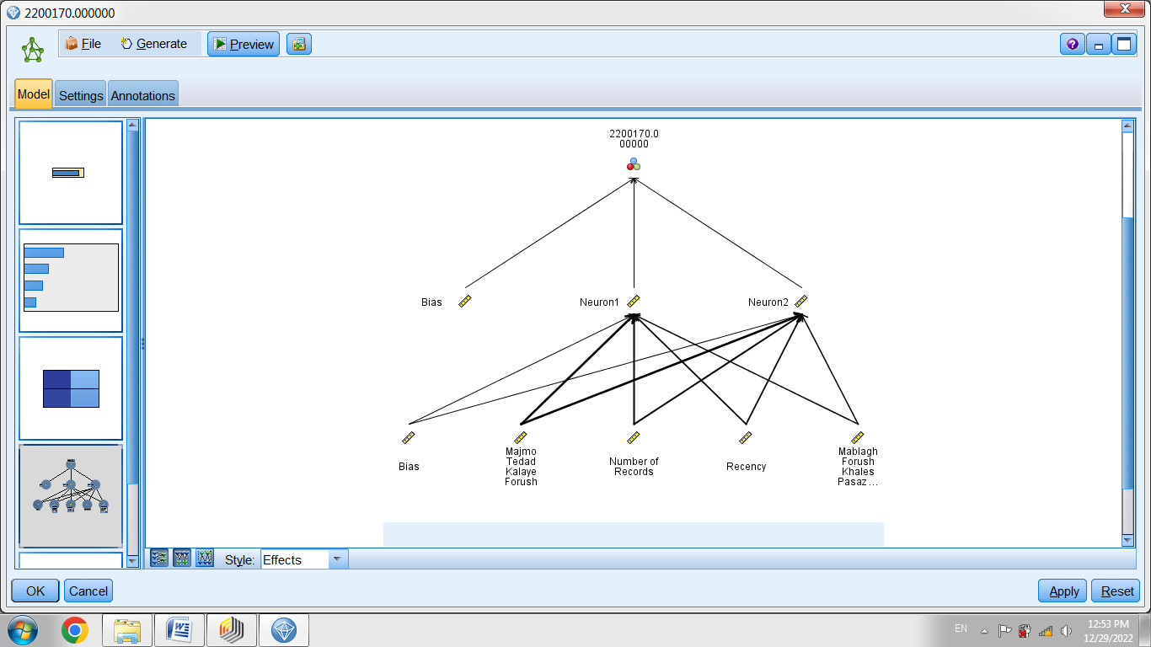

4. Another method is the classification of customers based on their leaving the store. Therefore, the customer leaving variable is determined as the target attribute in the dataset. To classify customers based on customer leaving, a period is defined in which customers who have not had a transaction during that period are classified as leaving customers. The results of the implementation of the neural network model are as follows. In this method, goods variables are included as input variables, and customer leaving variable is considered as target variables. In this regard, RapidMiner software is used. Also, the second cluster is considered as a dataset in terms of better performance. The procedure is as follows. First, the dataset of the second cluster, which is related to more valuable customers, is recalled. The operation is performed in the RapidMiner software. RapidMiner software can be used to filter the data of the second cluster.

Decision tree

Accuracy

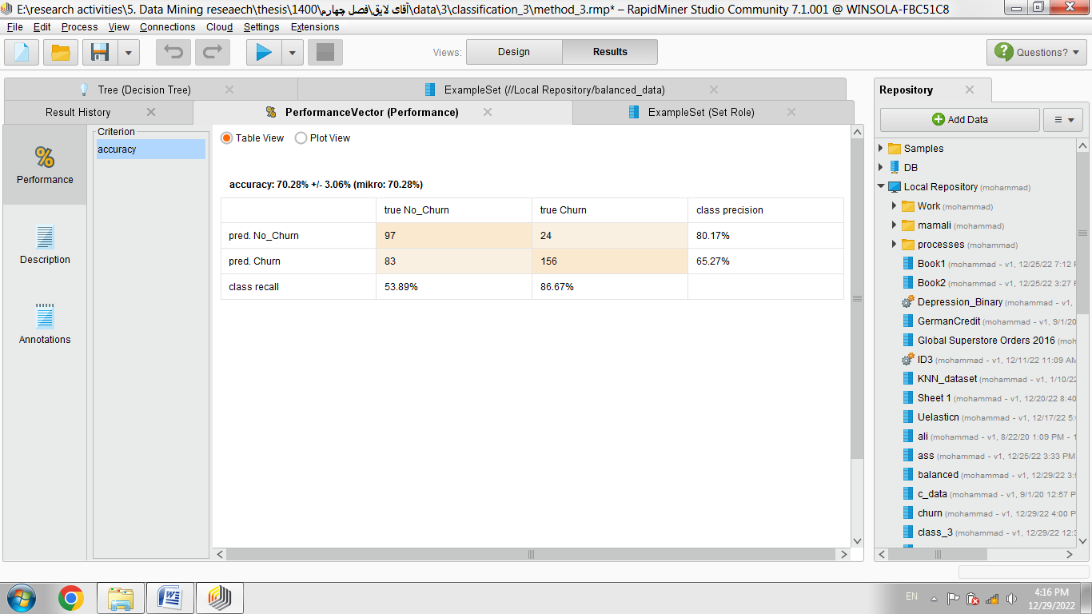

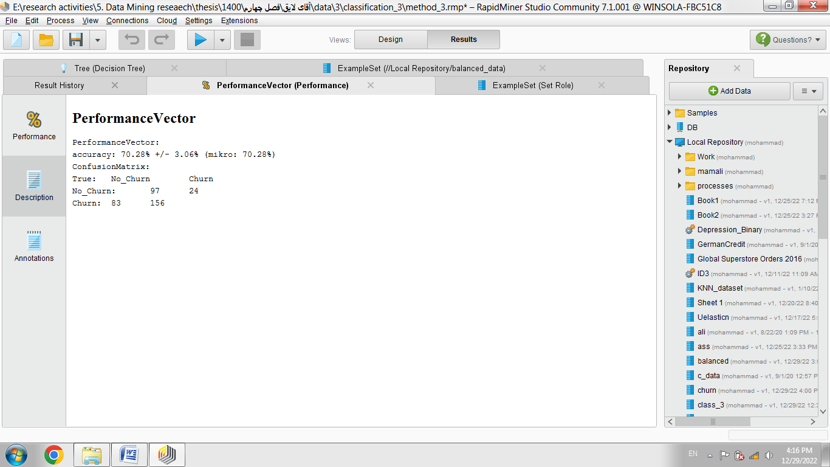

Tree sample

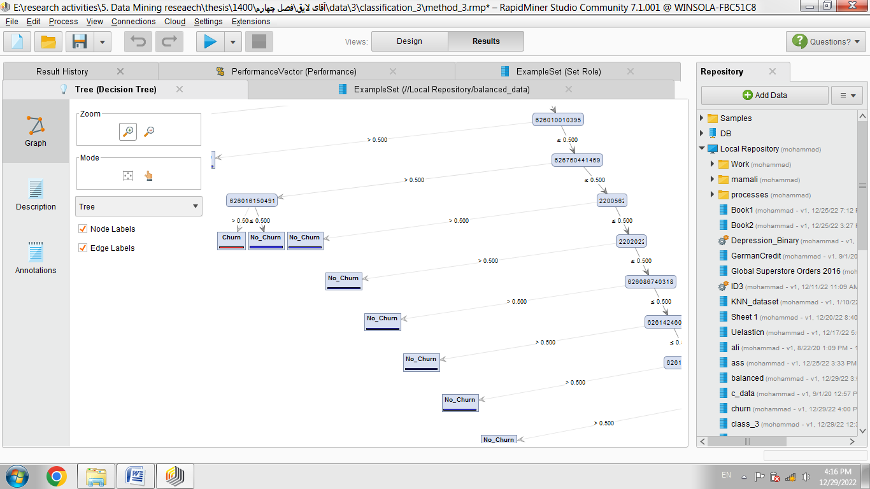

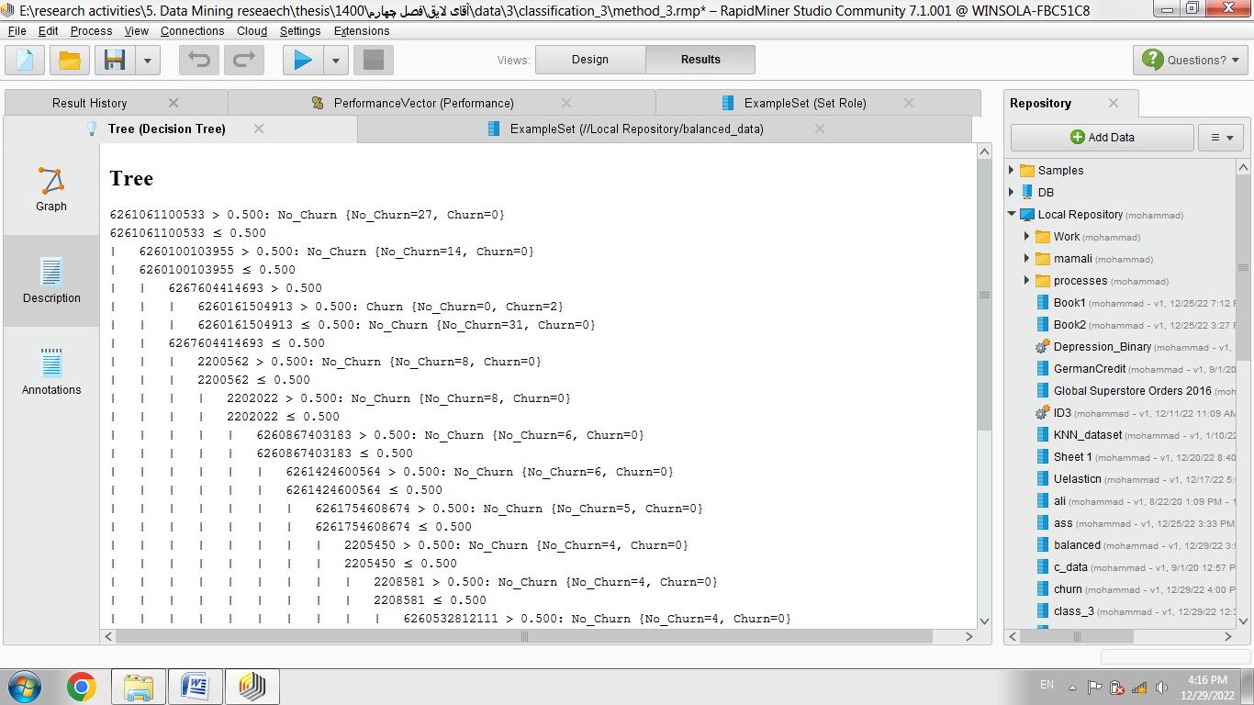

KNN method with K equal to 4

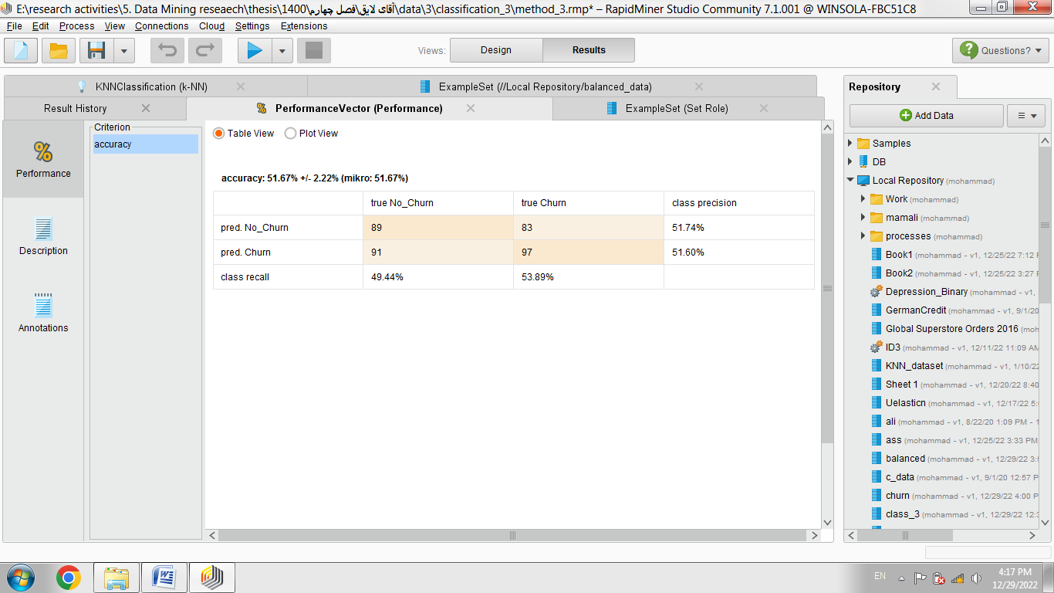

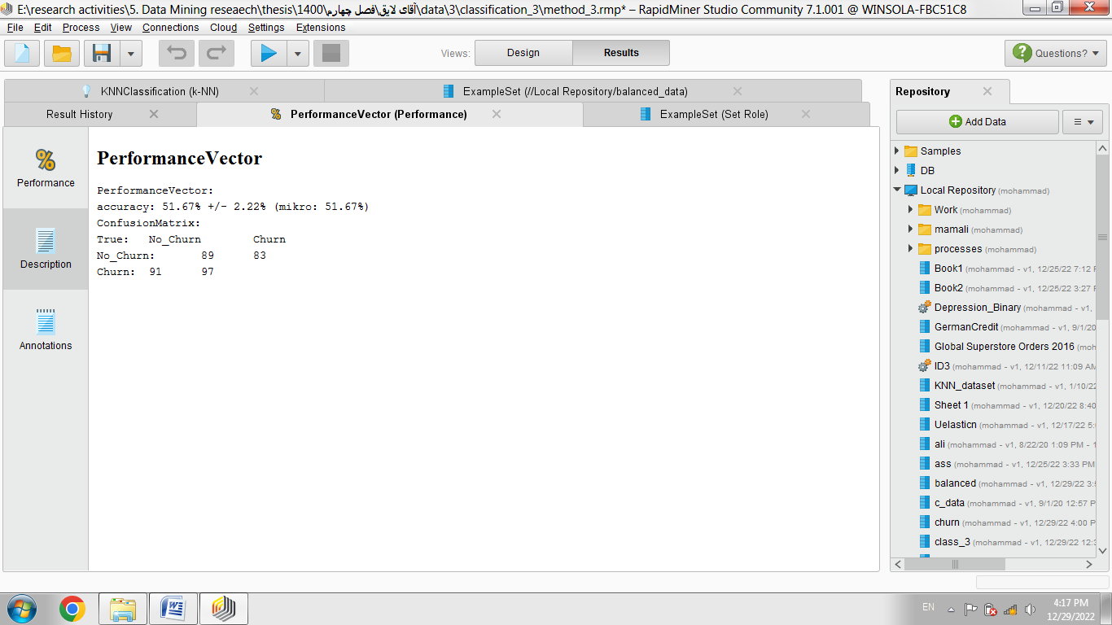

One of the methods is to cluster customers based on their preferences. Customer preferences in this method mean to purchase goods. For example, customers may have similar purchasing patterns in a cluster. Thus, we first consider each product as an attribute and then decide whether each customer purchases or not to purchases. Finally, these goods are identified as attributes of the dataset. By clustering, we can determine association rules in each cluster and identify frequent purchase patterns in each cluster. The results of K-means and SOM clustering methods are presented below. It is also possible to identify customer preferences based on the RFM variable and the customer leaving variable. For example, what are the preferences of valuable customers or what are the preferences of leaving customers?

First, we cluster the preferences of the customers who are more valuable than the first cluster and also the customers who do not leave.

The steps of the procedure are as follows:

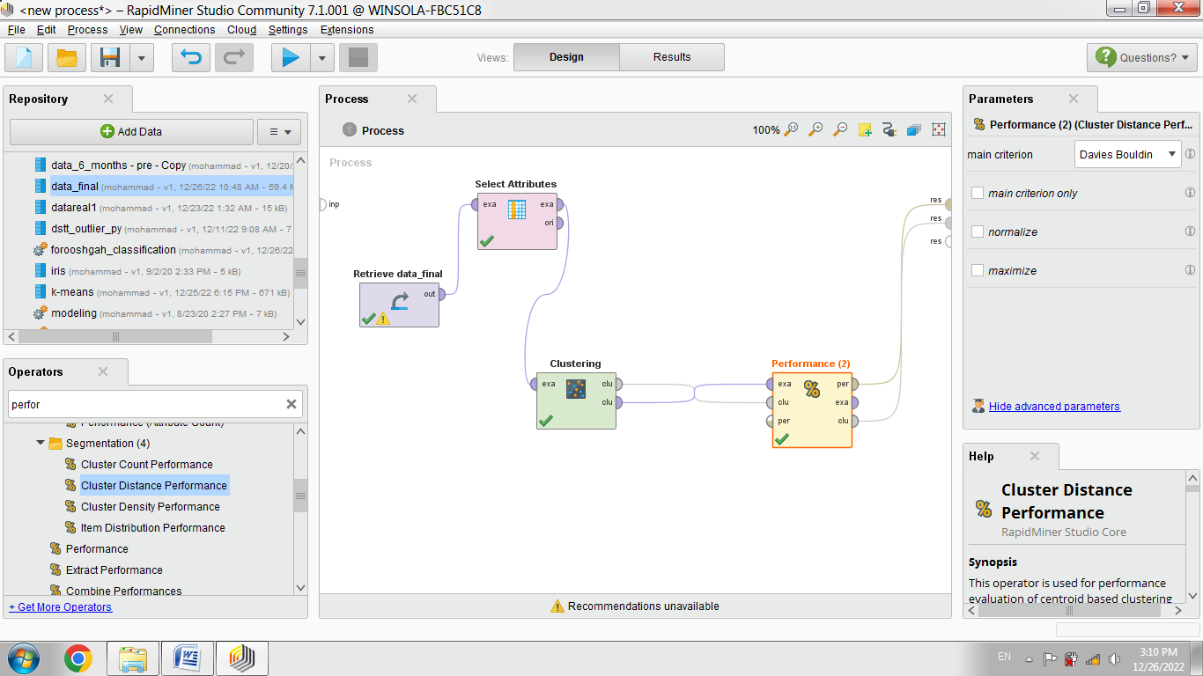

In two clusters, the Davies-Bouldin index is -4.91.

In 3 clusters, the value of this index is -3.46.

In 4 clusters, the value of this index is -4.84.

Therefore, the number of clusters is recommended to be 2. After determining the number of clusters into two clusters, it is possible to determine the association rules in each cluster. The number of customers in each cluster is as follows. The number of customers is 1644 in the first cluster and 211 customers in the second cluster. As an example, the association rules for the second cluster are determined. We should create this dataset. Therefore, we filter the customers of the second cluster. In this regard, the write CSV operator is used.

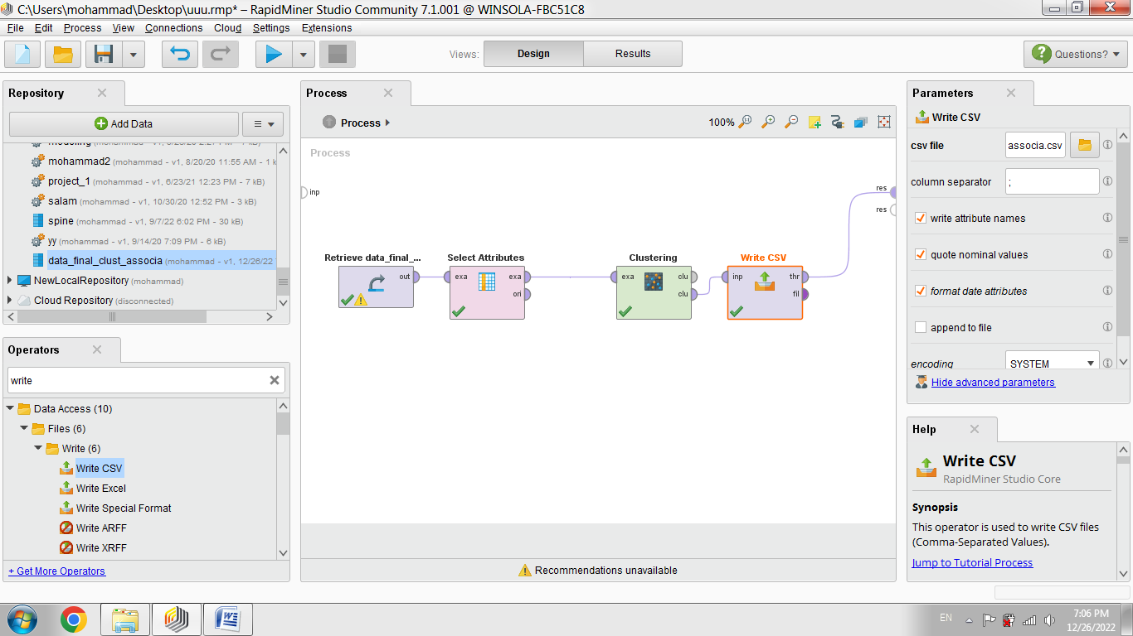

Then, we use the new dataset to create association rules. For this purpose, we use the following process.

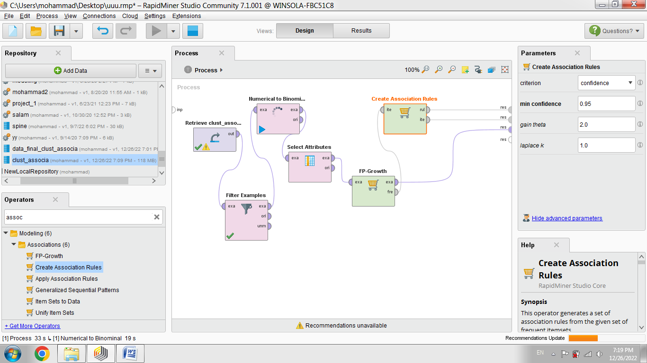

A filter example was used to filter the second cluster. Also, the minimum support and confidence value is 0.95.

Some frequent items and rules are as follows.

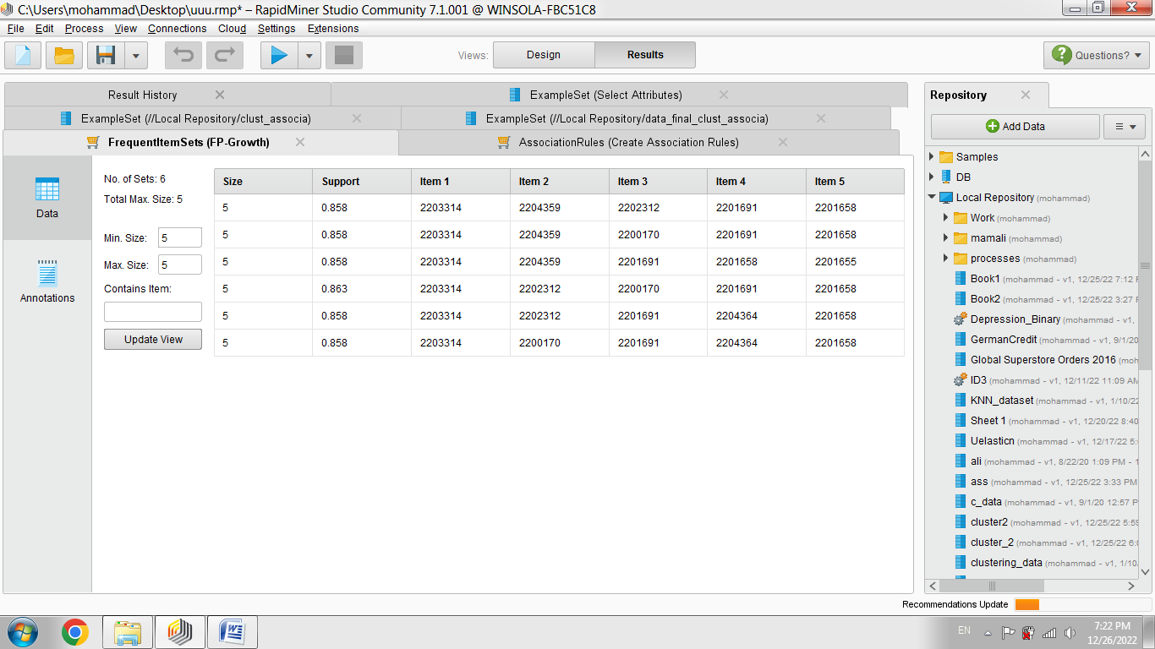

Also, some frequent patterns are as follows:

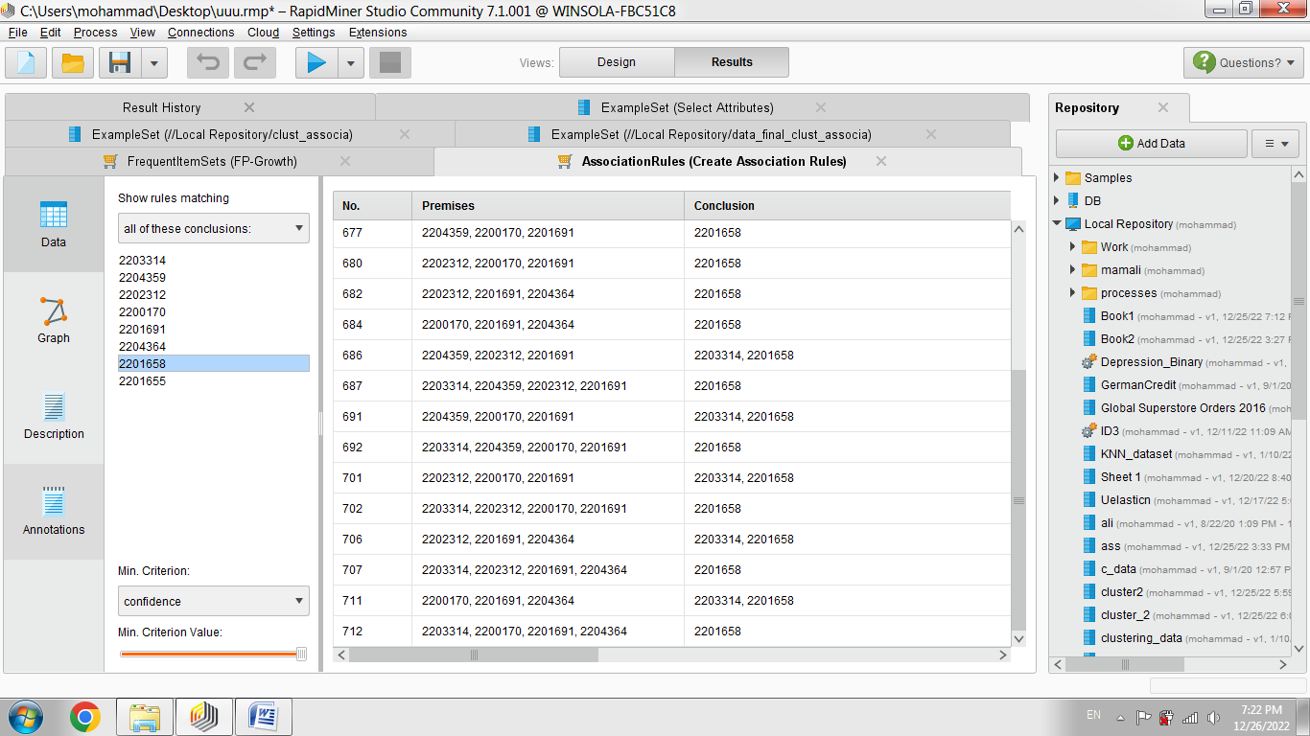

For example, some patterns for item 2204364 are as follows.

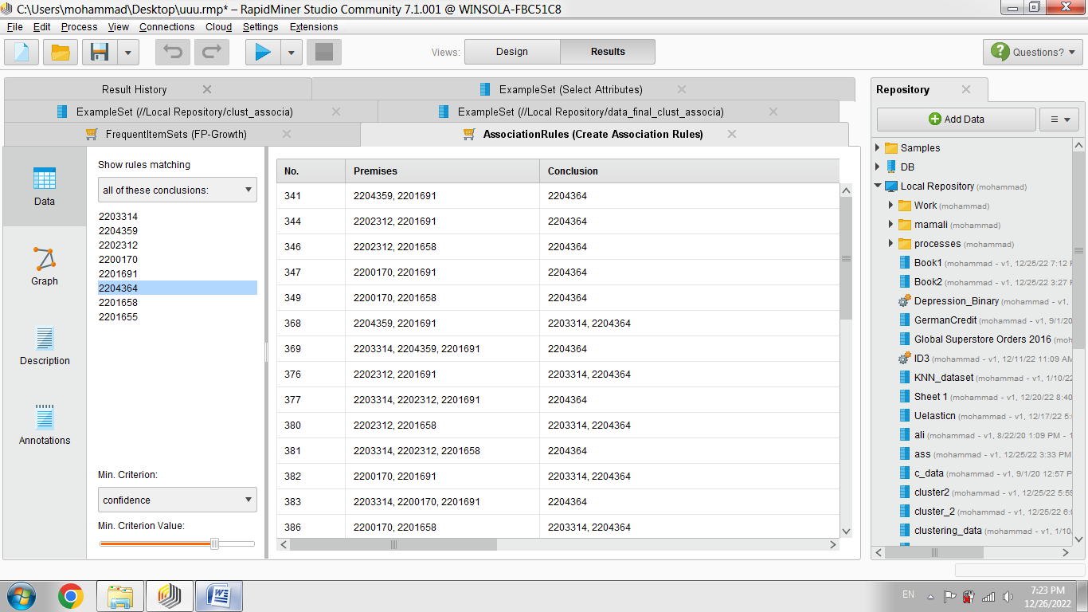

Also, some of the association rules related to this product are graphically shown below.

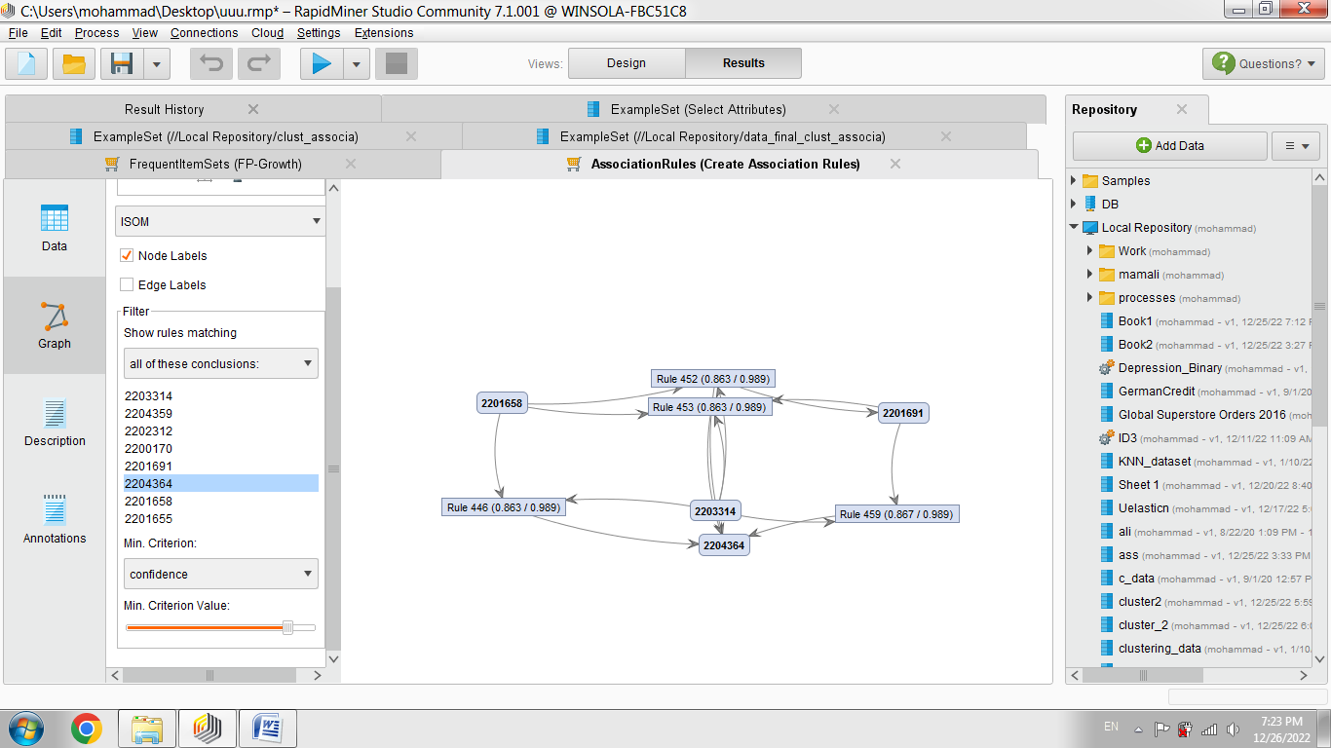

We can also find the association rules related to the customers who were in the second cluster, i.e. the valuable cluster, but have left.

# Discussion and Conclusion

The findings of the current study underscore the effectiveness of integrating neural network-based methods with clustering and association rule mining for the classification of valuable customers, prediction of customer churn, and extraction of customer preferences in chain food stores. The implementation of both Multi-Layer Perceptron (MLP) and Radial Basis Function (RBF) neural networks facilitated accurate classification models, achieving high precision rates—such as 98.44% accuracy using decision tree modeling for predicting product purchases. Furthermore, the use of K-means clustering effectively segmented customers into meaningful clusters, distinguishing between loyal and at-risk customers. Association rule mining added an additional analytical layer, revealing specific product associations and preference patterns among high-value, non-leaving customers. These results confirm that the hybrid application of machine learning techniques enables a granular understanding of customer behavior and contributes to more targeted marketing and retention strategies.

The high accuracy achieved in classifying customer behavior using neural networks aligns with the growing consensus in the literature regarding the superiority of machine learning techniques in handling large, complex datasets. As demonstrated in studies such as [2] and [3], neural networks are particularly adept at modeling nonlinear relationships between variables and can effectively learn from large-scale transaction histories. In the current study, neural networks not only demonstrated impressive classification power but also proved versatile in their application—being used for both purchase behavior prediction and churn analysis. Similarly, the application of clustering techniques, particularly K-means, aligns with findings from prior research indicating the usefulness of unsupervised learning for customer segmentation based on hidden behavioral traits [5, 17].

Another significant contribution of this study is its application of association rule mining to uncover customer preferences within identified clusters. The integration of this technique allowed the study to go beyond identifying churn risk and value segmentation to explore the products that tend to co-occur in high-value transactions. These findings resonate with prior work in the domain of preference analysis, such as [16], who used sequential pattern mining to identify latent customer preferences, and [10], who demonstrated that deep learning and collaborative filtering approaches can uncover precise product affinity patterns when trained on social and behavioral data. The present study builds on these findings by integrating rule mining directly into the clustering and classification pipeline, offering a novel and practically relevant contribution to customer analytics.

The emphasis on the value of behavioral indicators, such as recency, frequency, and monetary (RFM) scores, in predicting churn also finds support in the literature. Prior studies, including [8, 12], have shown that RFM variables are strong predictors of both future customer value and churn likelihood. This study confirmed that customers with higher values in these metrics were more likely to be retained and to exhibit consistent product preferences, further validating the predictive power of these variables in customer life cycle analytics. Moreover, by defining churn as the absence of transactions over a specified period, the study operationalized a dynamic model of customer loyalty, as encouraged by [4], who emphasized the need for real-time behavioral tracking in churn prediction systems.

The results also show that valuable customers tend to exhibit high inter-product association in their purchases, which suggests that product bundling strategies could be developed based on these insights. This finding is consistent with the research of [14], who used purchasing data to support product design features aligned with customer preferences. By using similar purchasing datasets, the current study reveals that association rules derived from high-value customers' behaviors can be used to tailor offerings, marketing messages, and even inventory decisions. This level of specificity is valuable for chain stores where shelf space and promotional campaigns must be optimized.

The ability to predict customer leaving behavior using neural network classification also confirms and extends earlier work. As shown in studies like [6] and [7], the combination of artificial neural networks with feature selection and hybrid algorithms results in superior churn prediction models. The current research supports these claims by demonstrating that neural networks, when applied to a refined dataset after pre-processing and feature selection (using principal component analysis), deliver reliable and actionable outputs. This strengthens the argument that AI-based churn models can enhance customer relationship management systems by identifying at-risk customers in a timely manner.

From a business intelligence standpoint, the study’s integration of neural models and association rules into a cohesive analytical pipeline also aligns with recent frameworks in organizational analytics maturity. For instance, [11] emphasized that advanced analytics tools such as machine learning models are pivotal to elevating business intelligence maturity from descriptive analytics to prescriptive decision-making. This study reflects that shift by offering practical, evidence-based strategies derived from high-dimensional customer data.

Moreover, the integration of preference modeling with value segmentation in this study supports the holistic view of customer profiling advocated in [13] and [18], where emotional, contextual, and behavioral factors are considered in tandem. Instead of viewing value, preference, and churn risk as independent constructs, this study presents them as interrelated components of a unified customer model. This approach also echoes findings from [15], who showed that customer preferences in a clustered environment reflect deeper socio-demographic and psychographic commonalities, especially in markets where religious or ethical dimensions influence purchasing decisions.

Despite the promising results, this study is not without limitations. First, the dataset was sourced from a single food retail chain (Kashan Amirkabir store No. 27), which may limit the generalizability of findings across diverse retail contexts. Customer behaviors, preferences, and churn patterns may differ in other regions, cultures, or sectors such as e-commerce or electronics retailing. Additionally, while the use of neural networks and clustering methods provided strong predictive capabilities, the black-box nature of neural networks sometimes makes interpretation and transparency challenging, particularly for managerial decision-making. The accuracy rates may also be partially influenced by overfitting to the specific transactional characteristics of the store's database. Moreover, the study's operational definition of churn as a lack of transaction in a defined time window may not capture the full complexity of why customers stop purchasing, such as dissatisfaction or external socioeconomic factors. Lastly, although association rules revealed useful product relationships, they may not fully account for causality or seasonal and promotional effects.

Future research should consider expanding the scope of analysis to multiple branches or different sectors to enhance the external validity of the model. It would be particularly beneficial to compare food retailing datasets with those from apparel, electronics, or online platforms to observe sectoral differences in predictive accuracy and model robustness. Additionally, longitudinal data tracking customer behavior over time would enable the analysis of preference evolution and the temporal aspects of churn, adding richness to the current static analysis. Future studies could also explore the integration of sentiment analysis from customer reviews, social media, or service feedback to complement transaction-based data with unstructured behavioral insights. Further model optimization could involve testing additional deep learning architectures such as LSTM (Long Short-Term Memory) or Transformer-based networks that are suited for sequential purchase behavior prediction. Finally, incorporating explainable AI techniques could improve the interpretability of neural models, making the findings more accessible for decision-makers and marketers.

Organizations aiming to optimize customer relationship management should consider integrating clustering, classification, and association rule mining into a unified data analytics platform. Chain stores can utilize such models to identify high-value customers, detect early signs of defection, and tailor product recommendations based on purchasing patterns. The insights derived from customer segmentation and preference analysis can be used to inform inventory decisions, develop targeted marketing campaigns, and personalize loyalty programs. By leveraging neural network models, companies can automate predictive functions and reduce dependency on manual analysis, enhancing operational efficiency. Retail managers are also encouraged to invest in the necessary infrastructure and training to interpret complex AI-driven insights. Furthermore, these analytical techniques can assist in the co-creation of value by aligning product offerings with emerging customer needs and feedback trends.

**Authors’ Contributions**

Authors equally contributed to this article.

# Ethical Considerations

All procedures performed in this study were under the ethical standards.

**Acknowledgments**

Authors thank all participants who participate in this study.

# Conflict of Interest

The authors report no conflict of interest.

# Funding/Financial Support

According to the authors, this article has no financial support.

# References

[1] Y. Li, B. Hou, Y. Wu, D. Zhao, A. Xie, and P. Zou, "Giant fight: Customer churn prediction in traditional broadcast industry," *Journal of Business Research,* vol. 131, pp. 630-639, 2021/07/01/ 2021, doi: <https://doi.org/10.1016/j.jbusres.2021.01.022>.

[2] S.-S. Chen, B. Choubey, and V. Singh, "A neural network based price sensitive recommender model to predict customer choices based on price effect," *Journal of Retailing and Consumer Services,* vol. 61, p. 102573, 2021/07/01/ 2021, doi: <https://doi.org/10.1016/j.jretconser.2021.102573>.

[3] V. H. Vu, "Predict customer churn using combination deep learning networks model," *Neural Computing and Applications,* vol. 36, no. 9, pp. 4867-4883, 2024, doi: 10.1007/s00521-023-09327-w.

[4] J. Xu, J. Liu, T. Yao, and Y. Li, "Prediction and Big Data Impact Analysis of Telecom Churn by Backpropagation Neural Network Algorithm from the Perspective of Business Model," *Big Data,* vol. 11, no. 5, pp. 355-368, 2023/10/01 2023, doi: 10.1089/big.2021.0365.

[5] A. Muneer, R. F. Ali, A. Alghamdi, S. M. Taib, A. Almaghthawi, and E. A. Ghaleb, "Predicting customers churning in banking industry: A machine learning approach," *Indonesian Journal of Electrical Engineering and Computer Science,* vol. 26, no. 1, p. 539, 2022. [Online]. Available: <https://doi.org/10.11591/ijeecs.v26.i1.pp539-549>.

[6] R. Yahaya, O. A. Abisoye, and S. A. Bashir, "An Enhanced Bank Customers Churn Prediction Model Using A Hybrid Genetic Algorithm And K-Means Filter And Artificial Neural Network," 2021: IEEE, in 2020 IEEE 2nd International Conference on Cyberspace (CYBER NIGERIA), pp. 52-58. [Online]. Available: <https://doi.org/10.1109/CYBERNIGERIA51635.2021.9428805>.

[7] S. C. Ho, K. C. Wong, Y. K. Yau, and C. K. Yip, "A machine learning approach for predicting bank customer behavior in the banking industry," 2019: IGI Global, in Machine Learning and Cognitive Science Applications in Cyber Security, pp. 57-83. [Online]. Available: <https://doi.org/10.4018/978-1-5225-8100-0.ch002>.

[8] P. Lalwani, M. K. Mishra, J. S. Chadha, and P. Sethi, "Customer churn prediction system: a machine learning approach," *Computing,* vol. 104, no. 2, pp. 271-294, 2021, doi: 10.1007/s00607-021-00908-y.

[9] M. S. Hori and K. Mahdavi, "Designing a Model for Predicting the Credit Rating of Bank Customers Using a Hybrid Multi-Criteria Fuzzy Neural Network and Ant Colony Algorithm (Case Study: Post Bank Branches in Tehran Province)," *Management Research in Iran,* vol. 19, no. 1, pp. 91-116, 2015. [Online]. Available: <https://www.sid.ir/paper/501992/fa>.

[10] S. Shamshoddin, J. Khader, and S. Gani, "Predicting consumer preferences in electronic market based on IoT and Social Networks using deep learning based collaborative filtering techniques," *Electronic Commerce Research,* vol. 20, no. 2, pp. 241-258, 2019, doi: 10.1007/s10660-019-09377-0.

[11] J. Nazarian-Jashnabadi, M. Ronaghi, m. alimohammadlu, and A. Ebrahimi, "The framework of factors affecting the maturity of business intelligence," *Business Intelligence Management Studies,* vol. 12, no. 46, pp. 1-39, 2023, doi: 10.22054/ims.2023.74305.2346.

[12] S. Shokouhyar, P. Saeidpour, and A. Otarkhani, "Predicting Customers' Churn Using Data Mining Technique and its Effect on the Development of Marketing Applications in Value-Added Services in Telecom Industry," *International Journal of Information Systems in the Service Sector,* vol. 10, no. 4, pp. 59-72, 2018, doi: 10.4018/ijisss.2018100104.

[13] S. Shokouhyar, S. Shokoohyar, N. Raja, and V. Gupta, "Promoting fashion customer relationship management dimensions based on customer tendency to outfit matching: mining customer orientation and buying behaviour," *International Journal of Applied Decision Sciences,* vol. 14, no. 1, pp. 1-23, 2021/01/01 2021, doi: 10.1504/IJADS.2021.112932.

[14] J. Zhang, X. Chu, A. Simeone, and P. Gu, "Machine learning-based design features decision support tool via customers purchasing data analysis," *Concurrent Engineering,* vol. 29, no. 2, pp. 124-141, 2020, doi: 10.1177/1063293x20963313.

[15] A. Mahbubi, T. Uchiyama, and K. Hatanaka, "Capturing consumer value and clustering customer preferences in the Indonesian halal beef market," *Meat Sci,* vol. 156, pp. 23-32, Oct 2019, doi: 10.1016/j.meatsci.2019.05.012.

[16] L. Yu, Z. Zhang, and J. Shen, "Dynamic customer preference analysis for product portfolio identification using sequential pattern mining," *Industrial Management & Data Systems,* vol. 117, no. 2, pp. 365-381, 2017, doi: 10.1108/imds-12-2015-0496.

[17] T. Vafeiadis, K. I. Diamantaras, G. Sarigiannidis, and K. C. Chatzisavvas, "A comparison of machine learning techniques for customer churn prediction," *Simulation Modelling Practice and Theory,* vol. 55, pp. 1-9, 2015.

[18] A. Sharma, "Analyzing the Role of Artificial Intelligence in Predicting Customer Behavior and Personalizing the Shopping Experience in Ecommerce," *Interantional Journal of Scientific Research in Engineering and Management,* vol. 07, no. 02, 2023, doi: 10.55041/ijsrem17839.